Week 10 Task 2:

This is the original score:

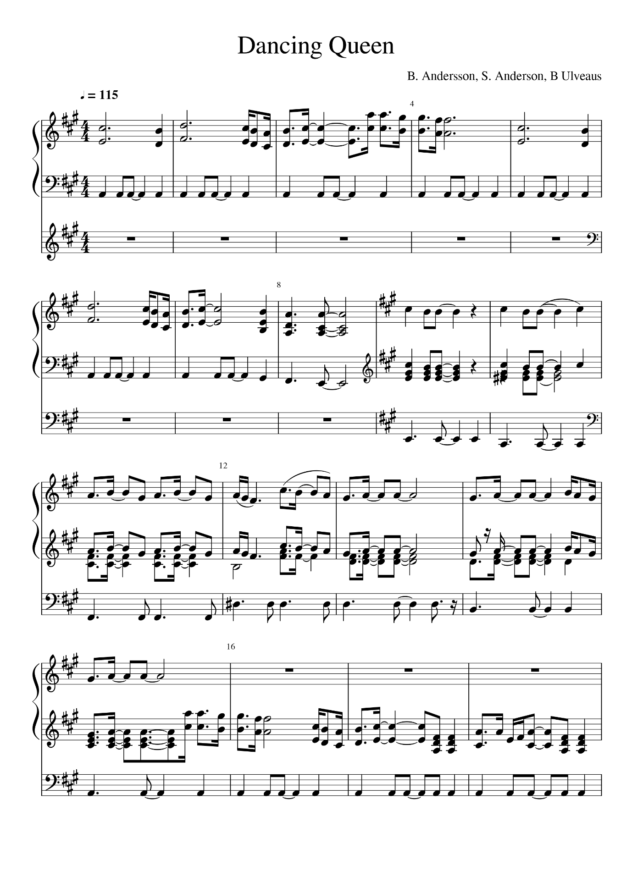

This is the score after transcription:

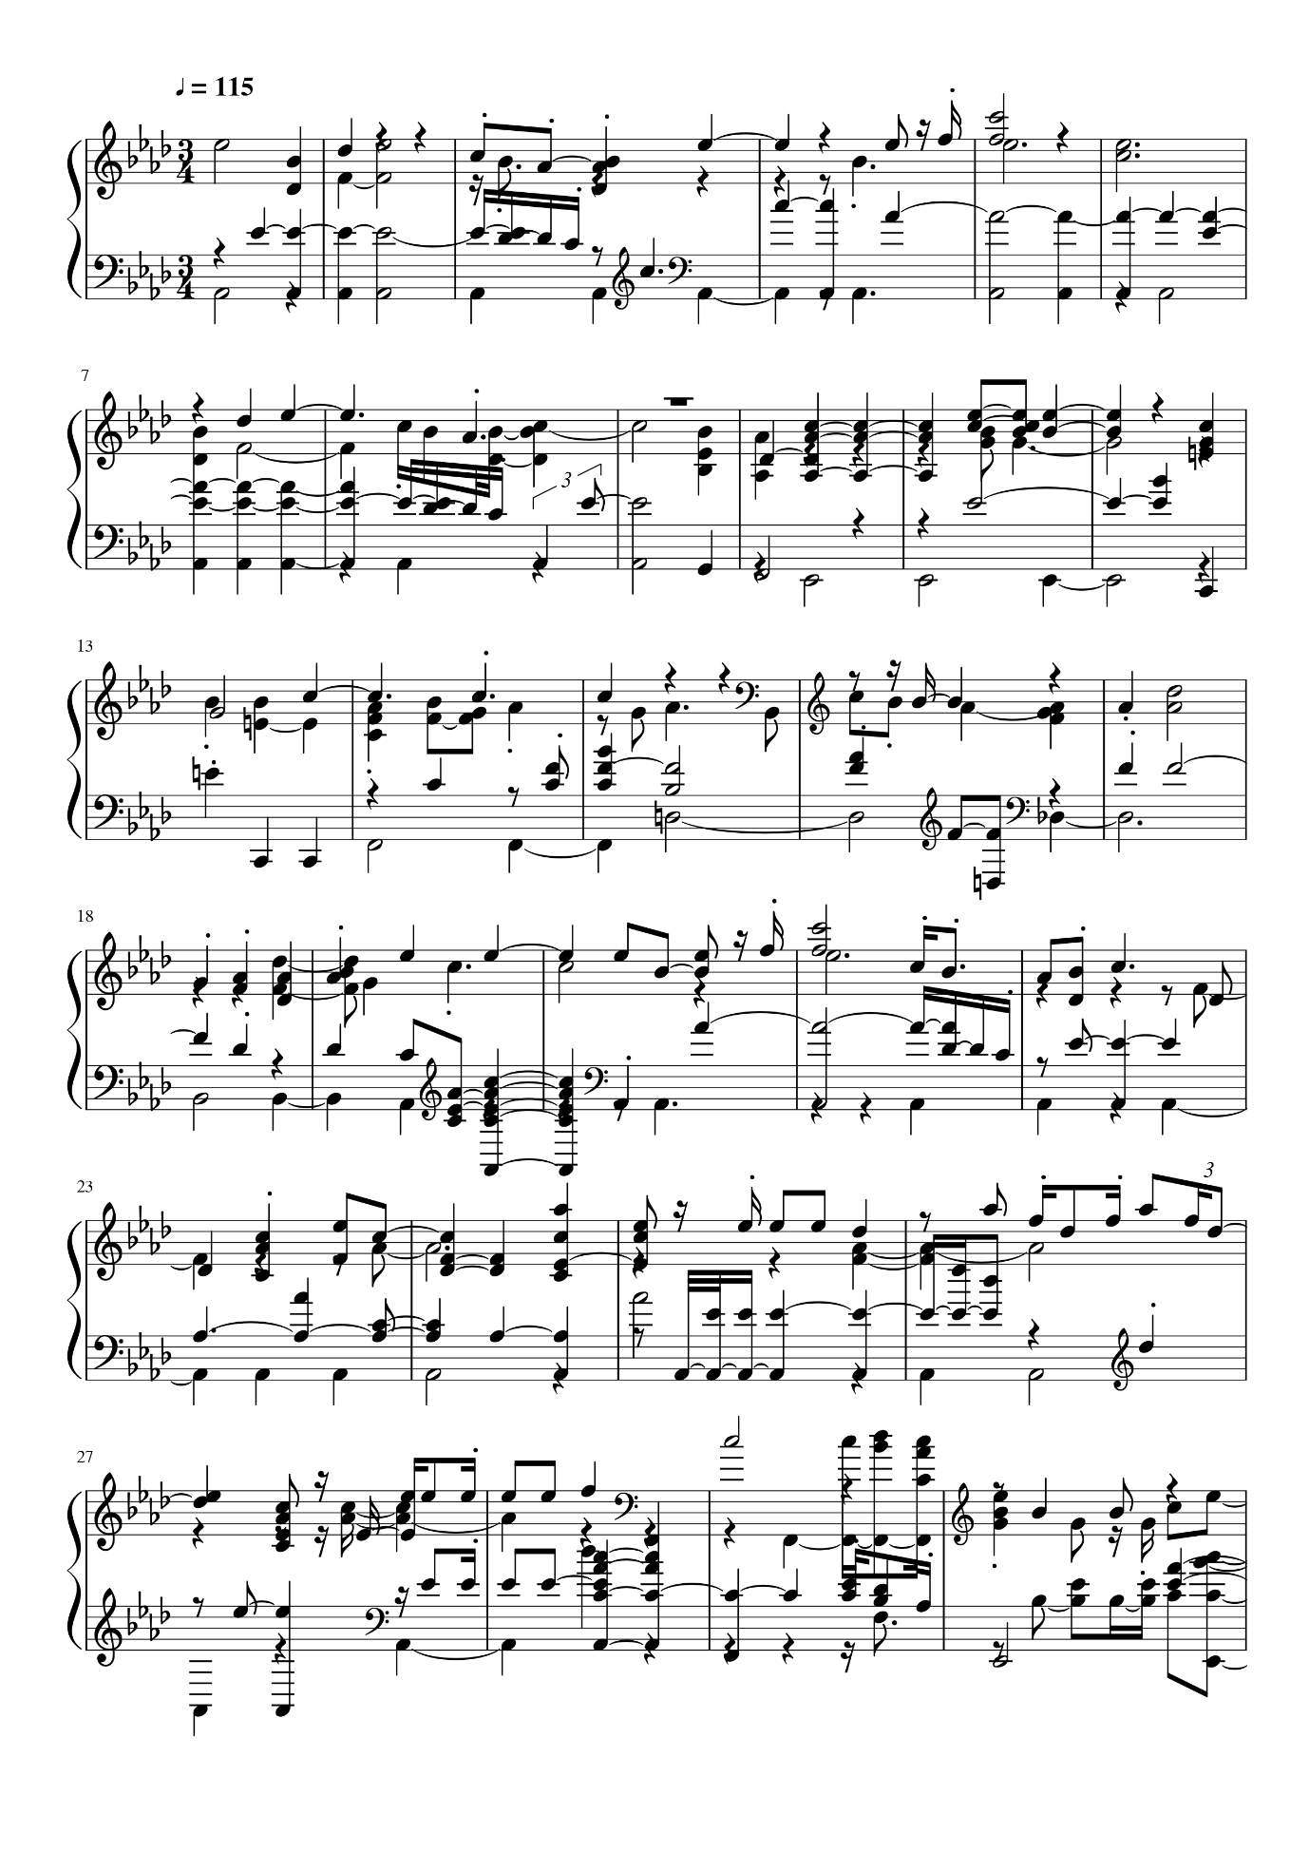

It’s clear to see the score has lost pretty much all of its integrity and the transcribed score bears very little resemblance to the original. This is a clear limitation of music curation software and something which evidently still needs to be further developed.